**Voice Mail – Guide**

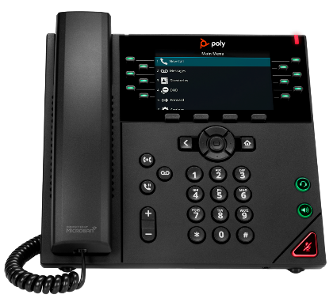**To Play voicemail messages or to access mailbox settings, start by pressing the voice mail button. You will know you have messages if the light on the top right is flashing or if you hear a series of beeps when picking up handset.**

**TO LISTEN TO MESSAGES – PRESS 1**

For new messages – press 1

For old messages – press 3

While listening to a message:

* To ​Rewind – Press 1
* To ​Pause – Press 2
* To ​Fast Forward​ – Press 3
* To listen to the Envelope (Time, date, phone number) – Press 4
* To start message at beginning – Press 5
* To Delete – Press 7
* To ​Skip​ – Press #
* For Help – Press 0
* For Previous Menu – Press *

**FOR VOICEMAIL SETTINGS - PRESS 4 (To record your greeting)**

***Admin Options – Press 1***

* To Change password – Press 1
* To Bypass password when accessing from your own phone – Press 2
* To Re-enable password when accessing from your own phone – Press 3
* For Remote Access – Press 4
* For Previous Menu – Press *

***To Record your Personal Greeting – Press 3***

* Press # when finished